**Project Report**

**Team Members :- 1. G.Bhanu chandar**

1. **C.Narasimha**
2. **K.Kishore babu**
3. **P.Venkata rama mohana sai**

# 1. INTRODUCTION

1.1Project Overview

The project aims to develop a system for predicting the growth stages of plants based on environmental factors (such as temperature, humidity, and soil conditions) and management practices (such as irrigation, fertilization, and pest control). This prediction model is built using Power BI, leveraging its powerful data visualization capabilities and integration with advanced analytics tools like R and Python. The system will help farmers, agricultural researchers, and decision-makers optimize agricultural practices to improve crop yield and ensure more efficient resource management.

1.2 Purpose

The purpose of this project is to develop a data-driven solution that predicts plant growth stages based on environmental and management data using Power BI. This project aims to provide agricultural professionals, researchers, and decision-makers with the tools to optimize crop yield, improve resource management, and enhance overall agricultural productivity. By leveraging the power of machine learning models and advanced data visualization, the project intends to:

1. **Enhance Agricultural Efficiency**: Provide insights that help optimize the use of resources like water, fertilizers, and pesticides, leading to more sustainable farming practices.
2. **Improve Crop Yield**: By accurately predicting plant growth stages and understanding environmental factors, farmers can make informed decisions that enhance crop health and maximize yield.
3. **Facilitate Data-Driven Decision-Making**: The project empowers agricultural stakeholders with real-time data and predictive insights, allowing them to make informed decisions based on environmental conditions, management practices, and predicted growth trends.
4. **Optimize Management Practices**: Enable farmers to fine-tune their irrigation schedules, fertilization plans, and other management practices according to the predicted growth stages of plants, improving productivity and reducing waste.
5. **Bridge the Gap Between Data and Action**: By integrating machine learning into Power BI’s userfriendly interface, the project makes complex data analysis and growth predictions accessible to non-technical users in the agricultural sector.

In essence, the project's purpose is to create a tool that helps bridge the gap between environmental data, management practices, and plant growth, thereby fostering smarter, data-driven agricultural practices.

# 2. IDEATION PHASE

2.1 Problem Statement

In modern agriculture, predicting plant growth stages accurately is a complex challenge that requires considering various environmental factors (such as temperature, soil moisture, and humidity) and management practices (like irrigation, fertilization, and pest control). Traditional methods of assessing plant growth rely heavily on manual observation and experience, which can be time-consuming, inconsistent, and prone to errors. Additionally, these methods often fail to leverage the full potential of available environmental and management data, leading to inefficiencies in resource use and suboptimal crop yields.

2.2 Empathy Map Canvas

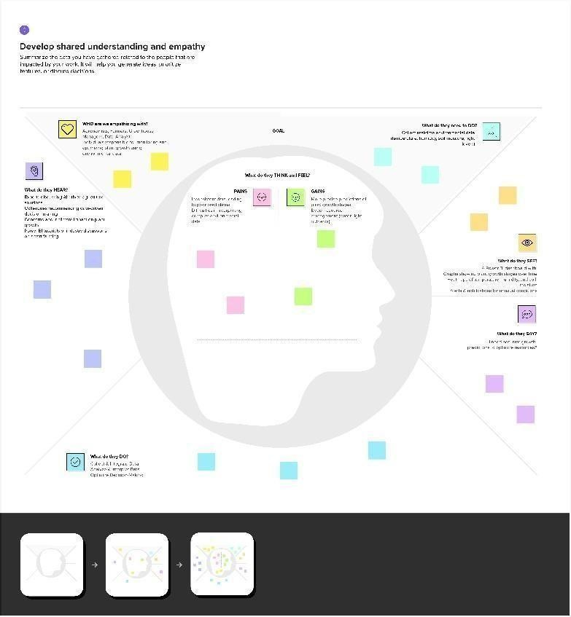

2.2 Brainstorming

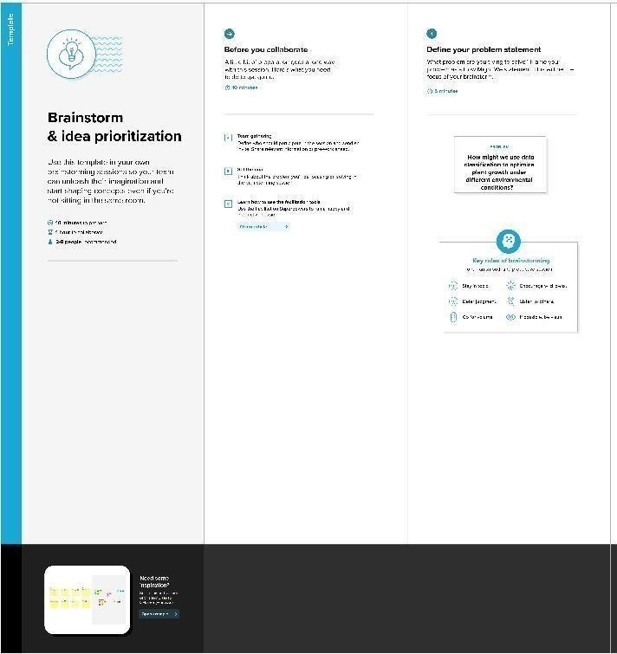

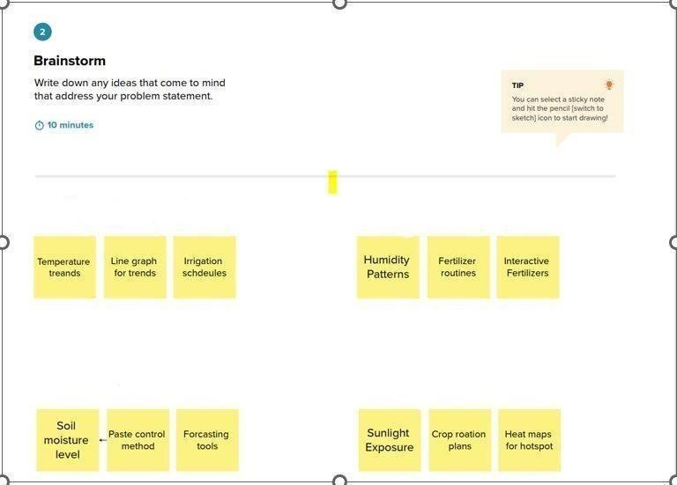

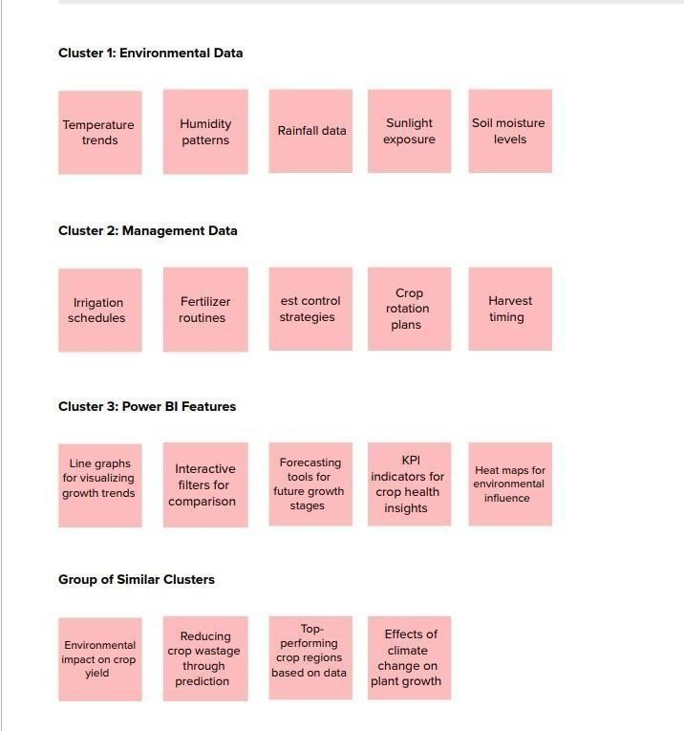

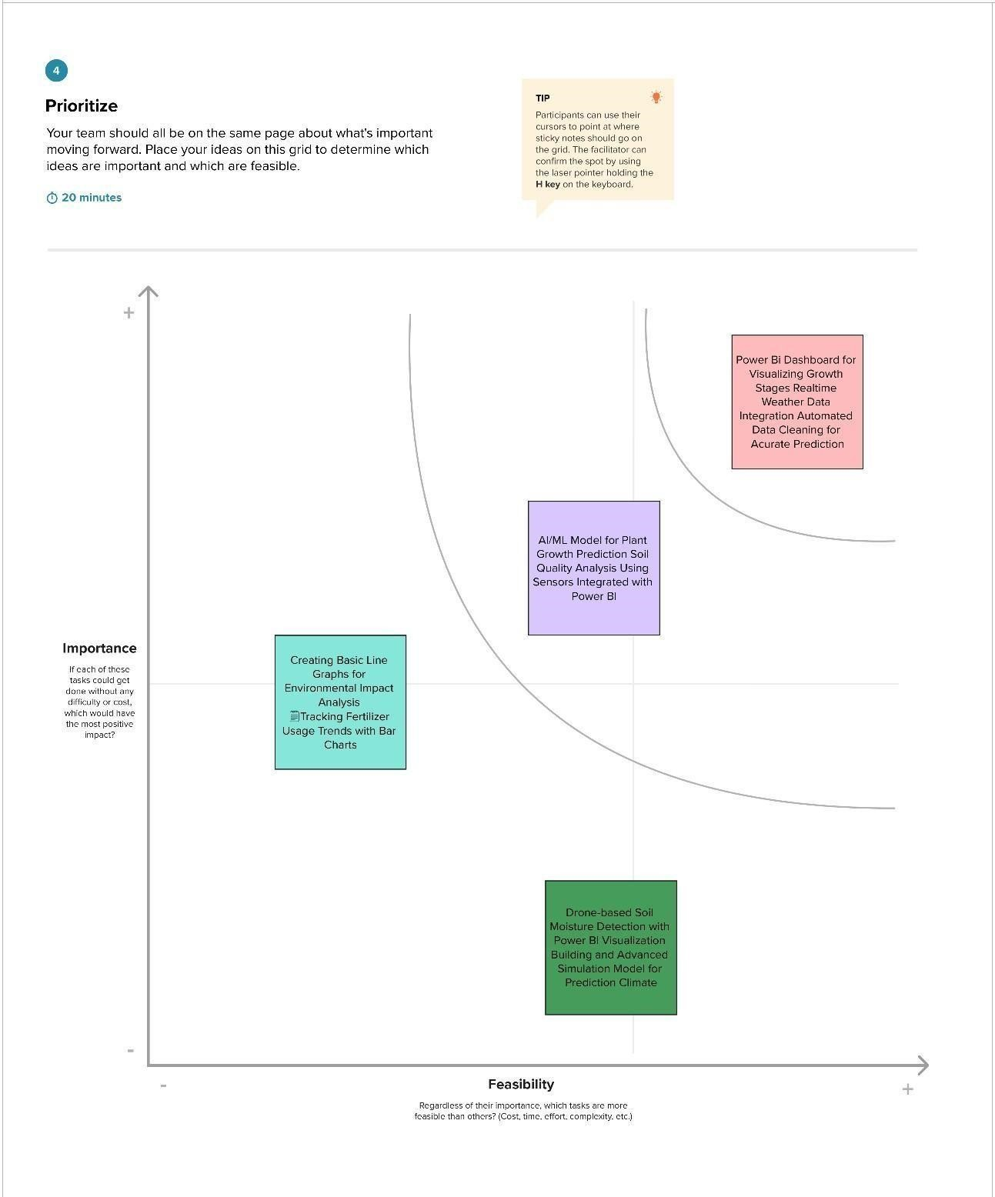

## 3. REQUIREMENT ANALYSIS

3.1 Customer Journey map

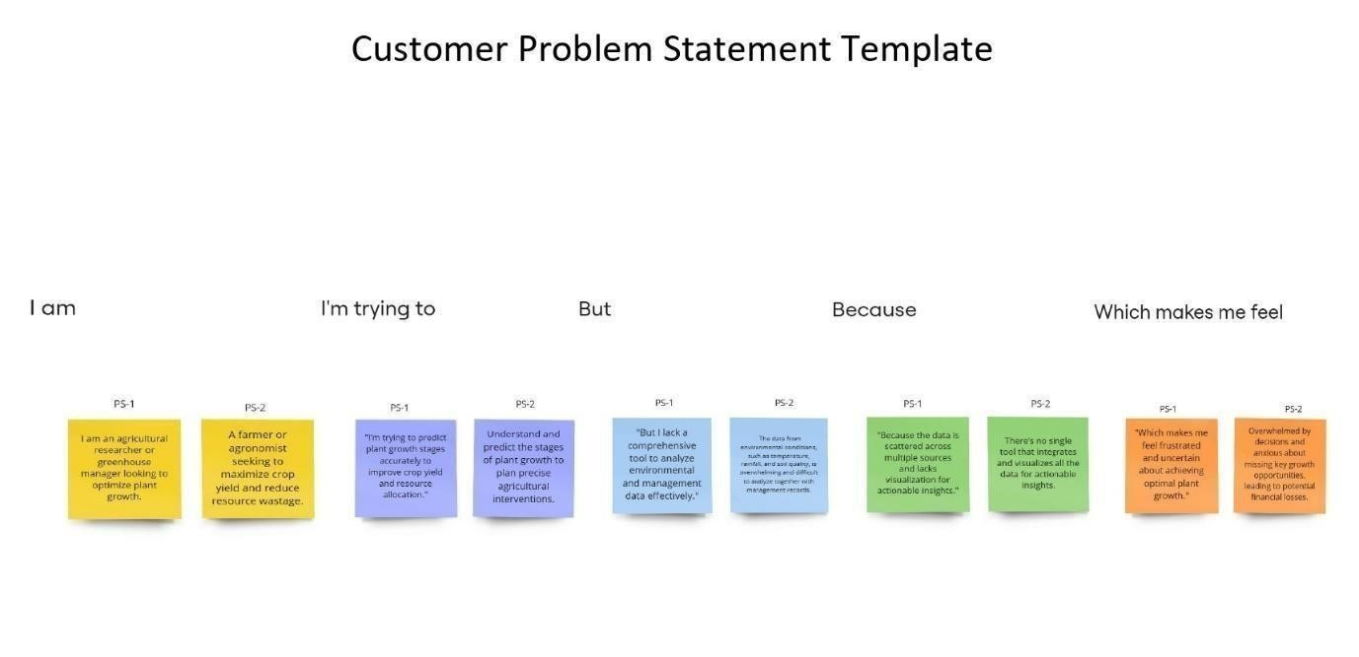

### 3.2 Solution Requirement

3.2.1 Functional Requirements

Following are the functional requirements of the proposed solution.

|  |  |  |
| --- | --- | --- |
| **FR No.** | **Functional**  **Requirement**  **(Epic)** | **Sub Requirement (Story / Sub-**  **Task)** |
| FR-1 | User Registration | * Registration through Form * Registration through Gmail * Registration through LinkedIn |
| FR-2 | User Confirmation | * Confirmation via Email * Confirmation via OTP |
| FR-3 | Data Integration | * Import Environmental Data * Import Management Data * Data Cleaning and Transformation |
| FR-4 | Data Visualization | * Create Dashboards in Power BI * Display Trends and Correlations * Generate Customized Reports |
| FR-5 | Prediction System | * Develop Machine Learning Models * Predict Plant Growth Stages Recommendations |

3.2.2 Non-Functional Requirements

|  |  |  |
| --- | --- | --- |
| NFR  No. | Non-Functional Requirement | Description |
| NFR-1 | Usability | The solution must have an intuitive and user-friendly interface. |
| NFR-2 | Security | Ensure secure data storage and user authentication. |
| NFR-3 | Reliability | The system should be highly dependable and provide accurate predictions. |
| NFR-4 | Performance | Maintain fast processing and data visualization even with large datasets. |

3.2 Data Flow Diagram

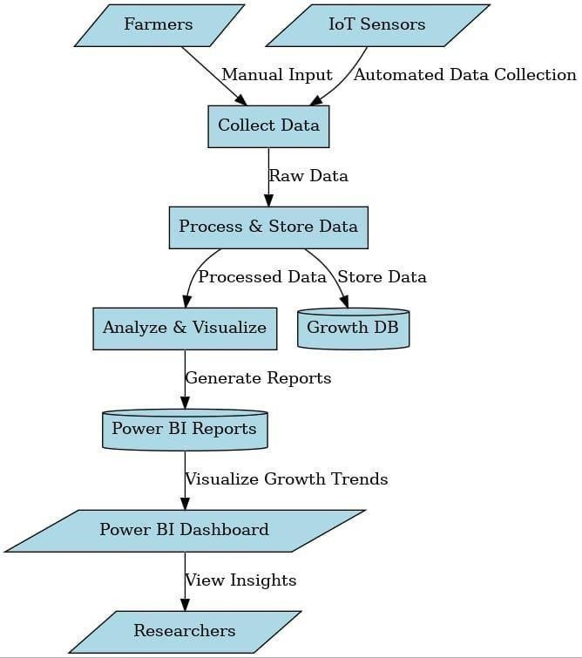

### 3.4 Technology Stack

Table 1: Application Components

|  |  |  |  |
| --- | --- | --- | --- |
| **Tim** | **Component** | **Description** | **Technology** |
| 1 | User Interface | User interfaces like Web UI or Mobile Apps to interact with the Power BI dashboards | HTML, CSS,  JavaScript, ReactJS |
| 2 | Application Logic-  1 | Data ingestion logic to extract environmental and management data from various sources | Python |
| 3 | Application Logic-  2 | Speech-to-text logic for audio input (e.g., voice commands for querying plant growth stages) | IBM Watson STT service |
| 4 | Application Logic-  3 | Virtual assistant to answer user queries related to plant growth predictions | IBM Watson Assistant |
| 5 | Database | Stores raw and transformed data, including historical plant growth and environmental  factors | MySQL, NoSQL |
| 6 | Cloud Database | Centralized storage of large-scale data for scalability | IBM Cloudant |
| 7 | File Storage | Storage for large environmental datasets and model output | IBM Block Storage or  Cloud-based storage |
| 8 | External API-1 | Provides real-time environmental data  (e.g., weather conditions) | IBM Weather API |
| 9 | External API-2 | Identity verification for restricted access  (if required) | Aadhar API |
| 10 | Machine  Learning  Model | Predicts plant growth stages based on input data | Custom ML Model  (developed in Python) |
| 11 | Infrastructure  (Server/Cloud) | Deployment of application on a cloud platform for scalability and availability | Kubernetes on IBM  Cloud |

Table 2: Application Characteristics

|  |  |  |  |
| --- | --- | --- | --- |
| **S.No** | **Characteristics** | **Description** | **Technology** |
| 1 | Open-Source Frameworks | Frameworks to build the application frontend or backend | ReactJS, Flask, Django |
| 2 | Security  Implementations | Implements access controls,  encryptions, and secure API calls | SHA-256, IAM  Controls, OWASP  Guidelines |
| 3 | Scalable  Architecture | Designed as microservices or a 3-tier architecture for scaling | Kubernetes, Docker |
| 4 | Availability | Load balancers and distributed servers ensure consistent access | Load Balancers, Distributed Cloud Servers |
| 5 | Performance | Performance optimization using caching and CDNs | CDN, Redis Cache |

## 4 PROJECT DESIGN

4.1 Problem Solution Fit

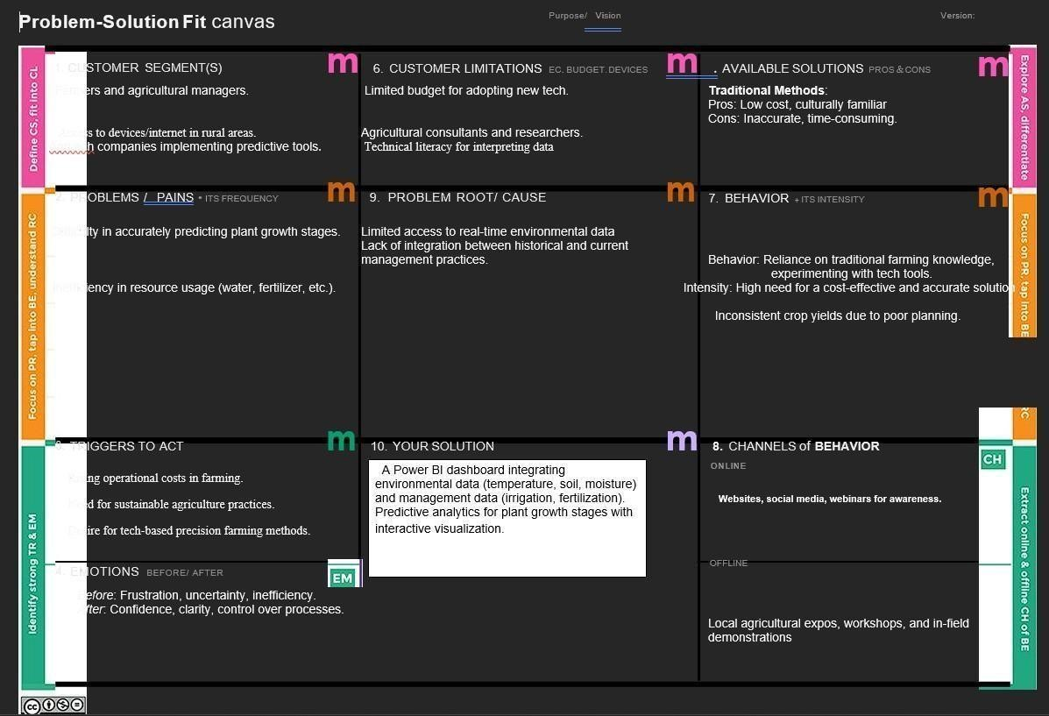

4.2 Proposed Solution

|  |  |  |
| --- | --- | --- |
| **S.No.** | **Parameter** | **Description** |
| 1. | Problem Statement | Clearly define the problem that the solution aims to solve. |
| 2. | Idea / Solution Description | Provide a detailed explanation of the proposed idea or solution. |
| 3. | Novelty / Uniqueness | Highlight the innovative aspects or unique features of the solution. |
| 4. | Social Impact / Customer  Satisfaction | Explain how the solution benefits society or improves customer experience. |
| 5. | Business Model (Revenue Model) | Describe the financial sustainability of the solution, including how revenue is generated. |
| 6. | Scalability of the Solution | Outline the potential for scaling the solution to reach larger markets or audiences. |

### 4.3 Solution Architecture

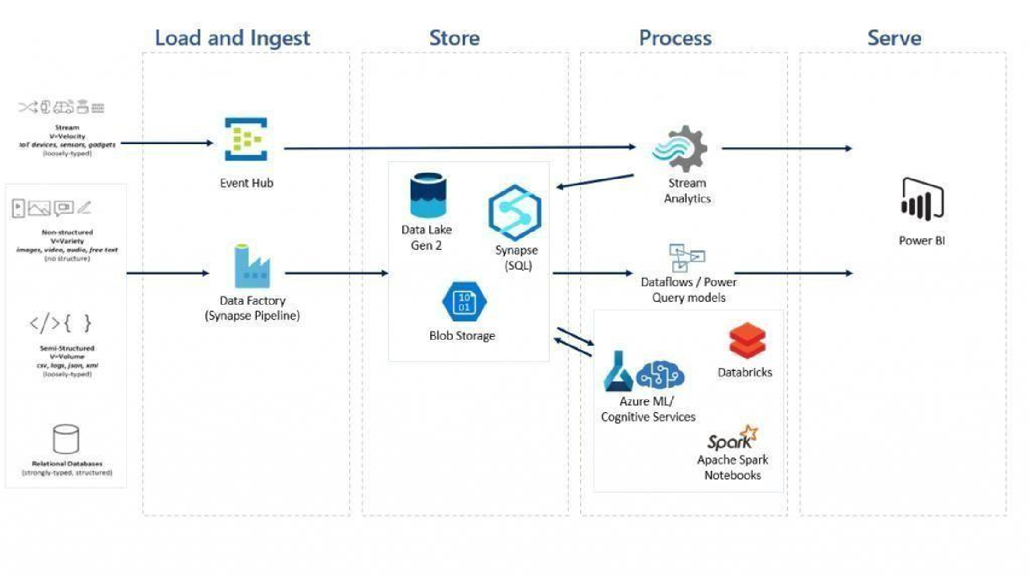

## 5. PROJECT PLANNING & SCHEDULING

### 5.1 Project Planning Product Backlog and Sprint Schedule

|  |  |  |  |  |  |  |
| --- | --- | --- | --- | --- | --- | --- |
| Sprint | Functional  Requirement  (Epic) | User  Story  Number | User Story / Task Description | Story  Points | Priority | Team  Members |
| Sprint-1 | Data  Collection and integration | USN-1 | Gather relevant environmental data, including temperature, humidity, soil moisture and light levels. | 7 | High | Yaswanth babu |
|  | Data preparation | USN-2 | Cleans the collected data for analysis. | 8 | High | Yaswanth babu, Jyothi Swaroop |
| Sprint-2 | Data Analysis and modelling | USN-3 | Utilize Power BI.s analytical tools to explore relationships between environmental factors and plants growth stages | 5 | Low | Karteeka  Raju, karthik |
|  | Visualization  Development | USN-4 | Create interactive  visualization for key metrics | 8 | Medium | Yaswanth  Babu,  Jyothi  Swaroop |
|  | Dashboard  Design | USN-5 | Design user-friendly interfaces that allow stakeholders to easily access and interpret data. | 8 | High |  |

### Project Tracker and Velocity

|  |  |  |  |  |  |  |
| --- | --- | --- | --- | --- | --- | --- |
| Sprint | Total Story Points | Duration  (Days) | Start Date | End Date (Planned) | Story Points  Completed  (Planned) | Release Date  (Actual) |
| Sprint-  1 | 24 | 5 | 13 Mar  2025 | 17 Mar 2025 | 24 | 26 Mar 2025 |
| Sprint-  2 | 24 | 5 | 17 Mar  2025 | 21 Mar 2025 | 24 | 26 Mar 2025 |

### Velocity Calculation

* Velocity = Total Story Points / Total Sprint Duration (in days).
* If the team's average velocity is 20 points per sprint (10-day sprint duration), Average Velocity (AV) = 2 story points per day.

### Burndown Chart

A burndown chart illustrates:

* X-axis: Sprint duration (time in days).
* Y-axis: Remaining story points.
* It starts with 20 story points at day 0 and decreases daily based on completed points.

## 6. FUNCTIONAL AND PERFORMANCE TESTING

**6.1 Performance Testing**

## 7. RESULTS

### 7.1 Screenshots of Report and observation

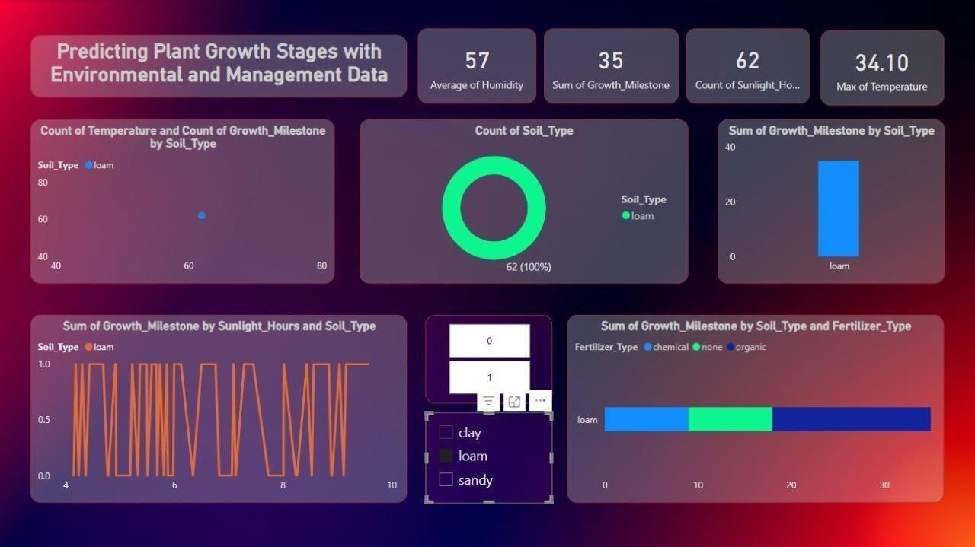

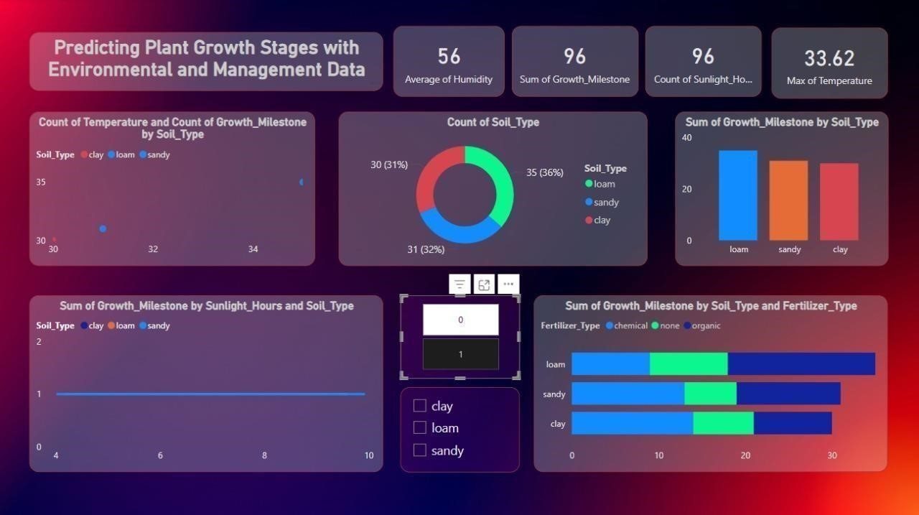

### 7.2 Screenshot of Dashboard and observation

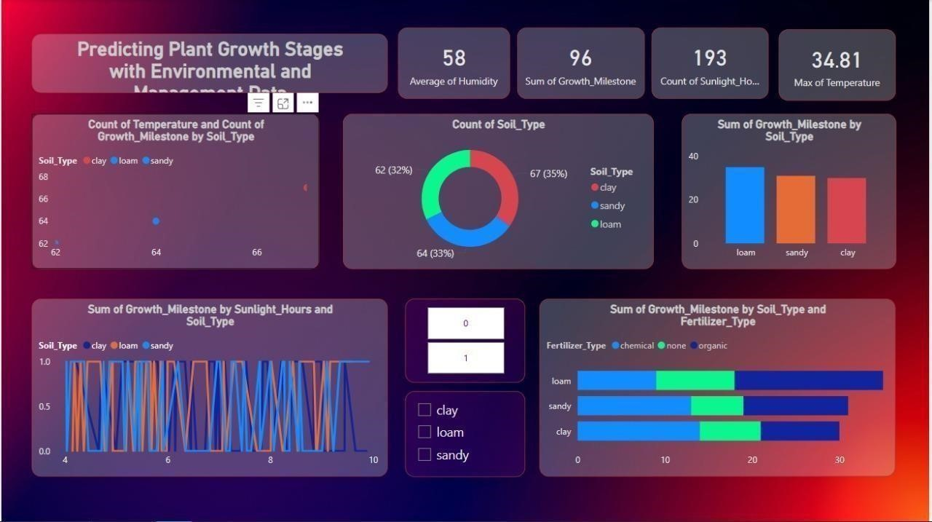

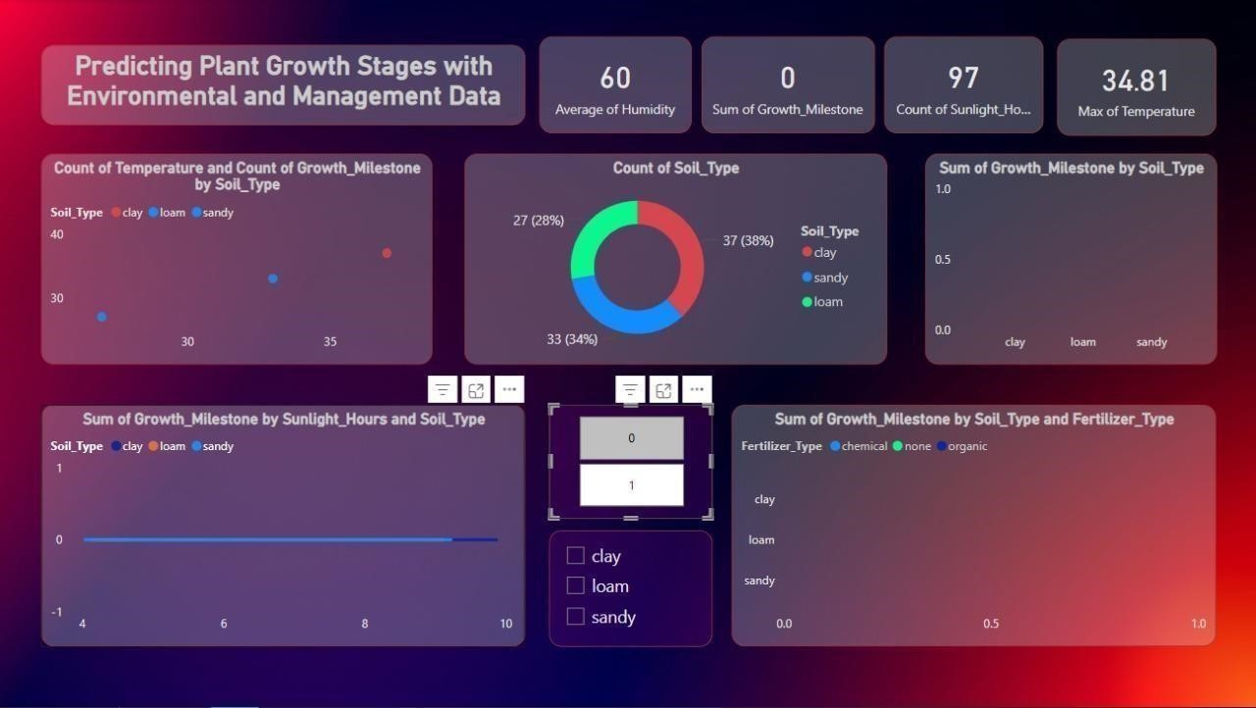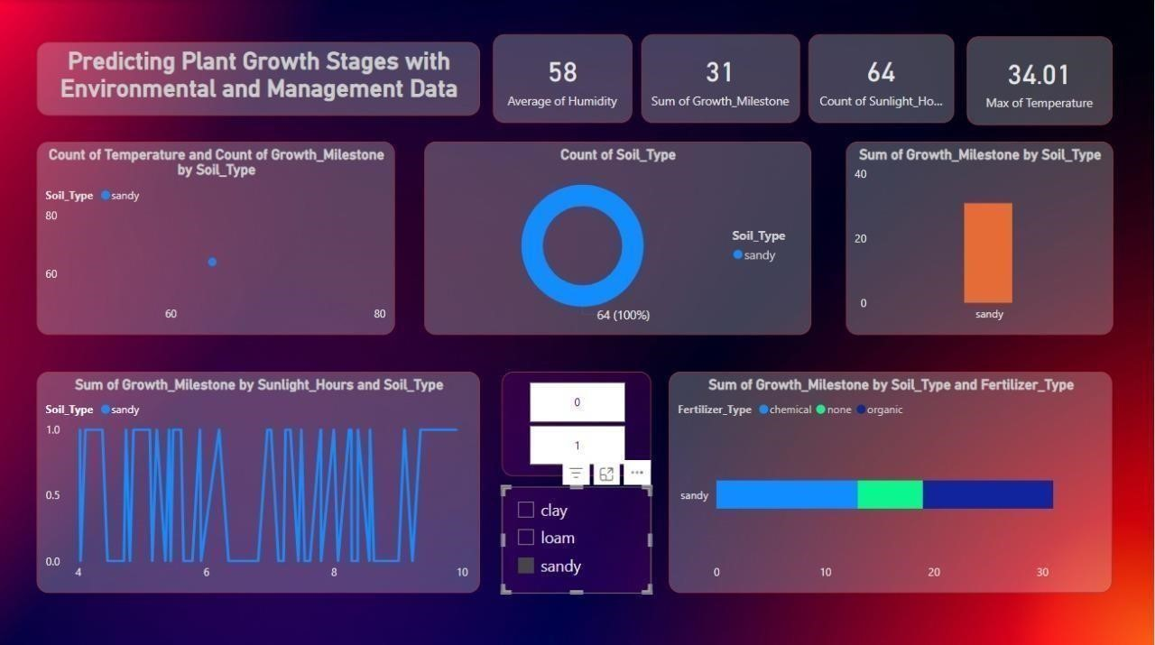



## 8. ADVANTAGES & DISADVANTAGES

### Advantages

1. Provides data-driven insights for better decision-making.
2. Increases productivity and optimizes resource use.
3. Scalable and user-friendly with Power BI’s visualizations.
4. Real-time environmental adaptation improves outcomes.

### Disadvantages

1. High initial cost and technical expertise required.
2. Depends heavily on data quality for accuracy.
3. Accessibility challenges in remote areas.
4. Requires ongoing maintenance and retraining.

## 9. CONCLUSION

The project successfully demonstrates the ability to predict plant growth stages using environmental and management data. The integration of machine learning models with Power BI provides farmers with actionable insights, which can improve resource utilization, crop yield, and overall farm productivity. The solution is scalable, and with continuous data collection, predictions will improve over time.

## 10. FUTURE SCOPE

Integration with IoT Devices: Real-time integration with environmental sensors can enhance prediction accuracy.

* Advanced Analytics: The system can be extended to provide more advanced analytics, like pest and disease prediction.
* Multi-Crop Support: Expand the model to predict growth stages for various crops.